**FACILITIES SERVICES**



**Project 03292021FIC**

**Addendum 1**

1. Section 011000 Summary for Contract Time shall read as follows: Time of Completion shall be 60 days from issuance of Purchase Order or Notice To Proceed which ever comes first.
2. All interior and exterior handrails are to be painted with Sherwin Williams Bulldog Maroon and cost included in the base bid.
3. All gutters, fascia and soffits are to be painted with Sherwin Williams Bulldog Maroon.
4. Soffit and fascia repair are not apart of the contractor’s responsibility.
5. Storage tanks, compressors and HVAC equipment is not part of this project.
6. Retaining wall shall be pressures washed and receive two coats of paint, color will be chosen by Owner. Cost shall be included in base bid. See pictures of locations below: Areas are Front entrance, South side of building and Interior Court Yard.

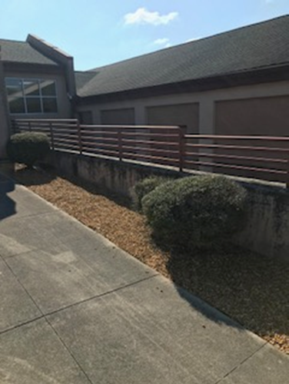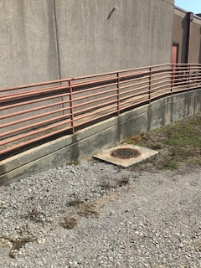

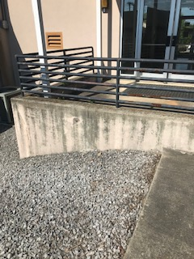

1. Repair hole at junction box and wall as shown on the pictures below: Areas shown are at the Front entrance, East wall and North wall.

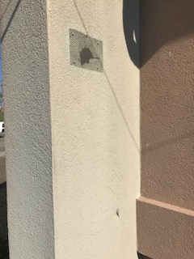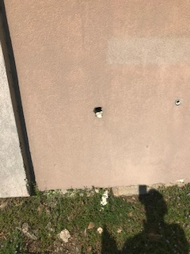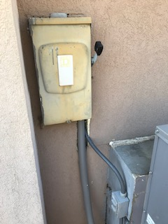

1. Paint all exterior grills with Sherwin Williams Bulldog Maroon.
2. Pressure wash interior Courtyard, Front entrance and entrances on the Westside of the building.
3. Paint interior hall and conference room wall with Sherwin Williams Agreeable Gray.
4. Replace 4-inch cove base in hall and conference room with 6-inch Maroon cove base and preformed corners.
5. Caulk front entrance where the slab meets the building and retaining wall after pressure washing see picture below:

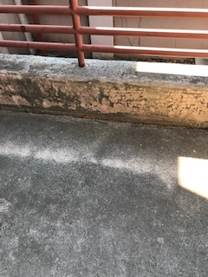

1. Pressure wash white canopies in the courtyard and North side of the building.
2. Remove from Section 01 23 00 Alternates 1.4 Schedule of Alternates
3. Alternate No. 1 Amount to be added to base bid if new gravel and associated work are included in contract for the existing dirt road per drawing A-0.0.
4. Replace wall louvers in the interior court yard as shown in the picture below:

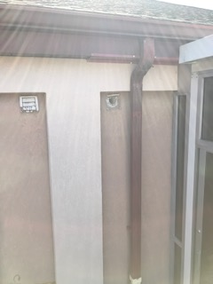

**End of Addendum 1**