COVID -19: Back to Campus (FALL 2020) Course
- If you have already created an account with a CITI Program username and password, click on the LOG IN tab and enter your credentials.
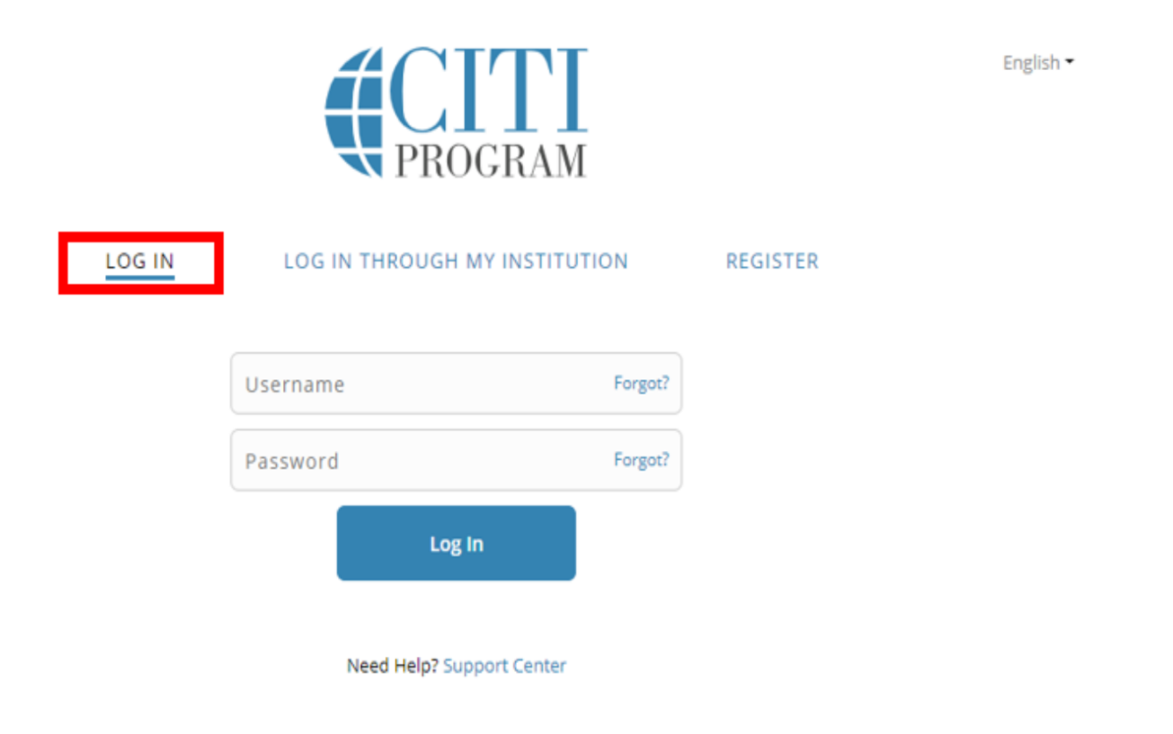

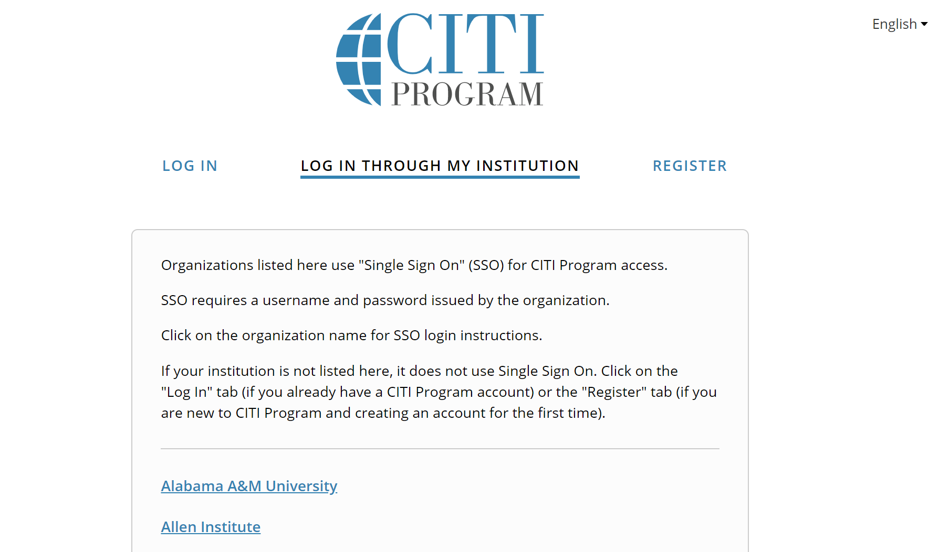
- If you have not created an account with CITI Program, click on LOG IN THROUGH MY ISTITUTION and click on Alabama A&M University.

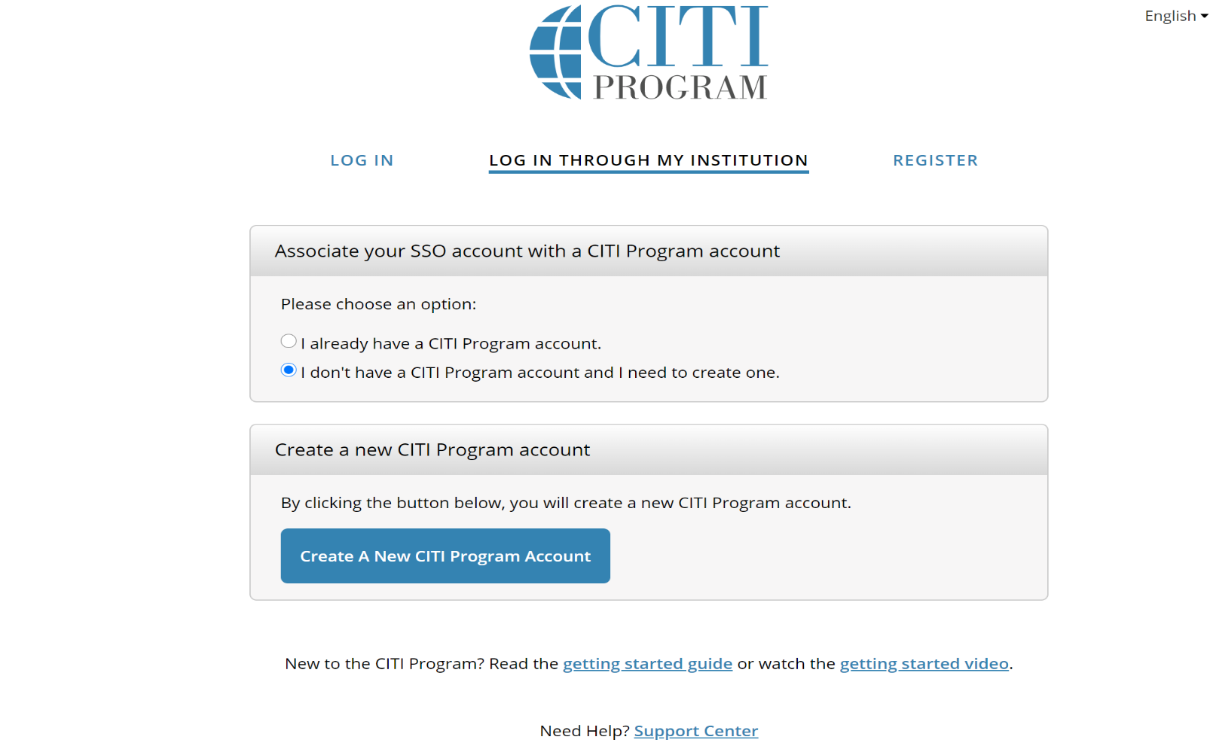
- Select the option I don’t have a CITI Program account and I need to login and click the blue tab, “Create a NEW CITI Program Account”.

- Select the “View Courses” Tab across from Alabama A&M University
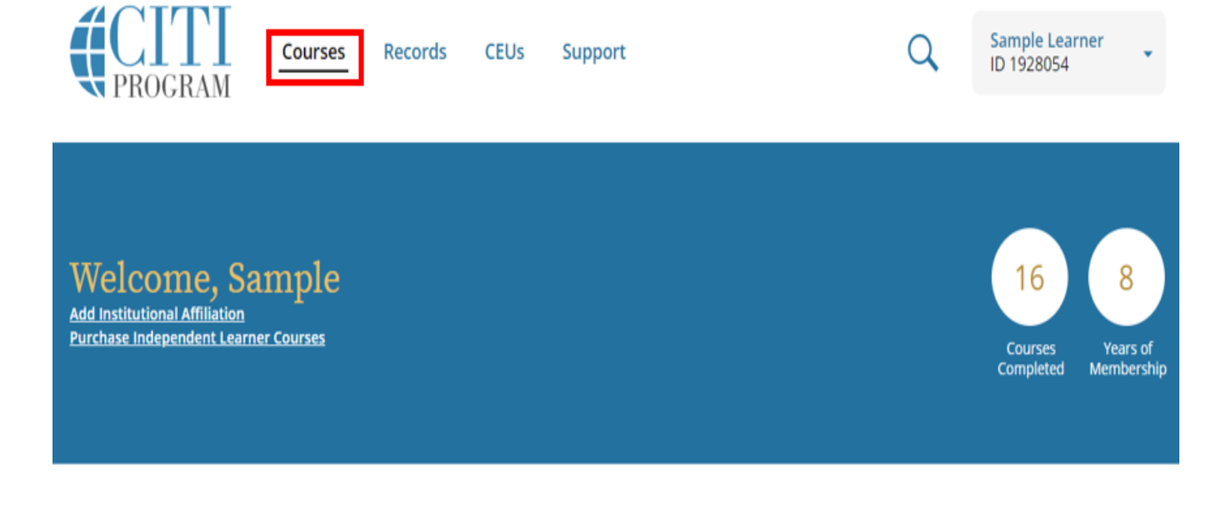
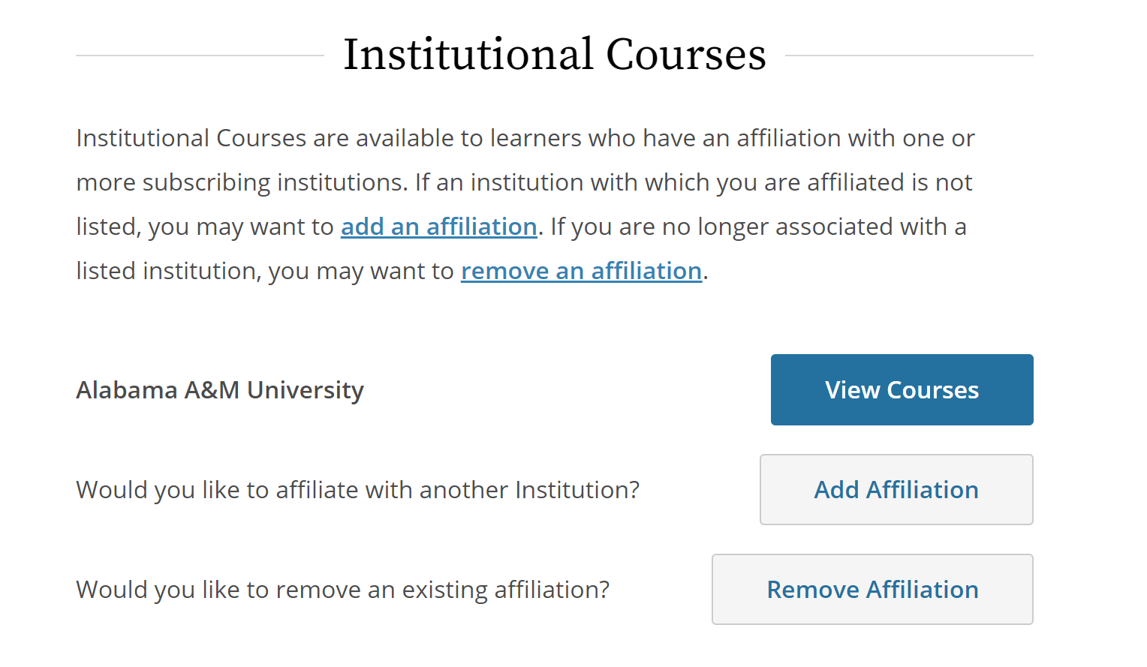

- Next you will need to add the COVID -19 Training Course to your account. Click on the tab, Add a Course
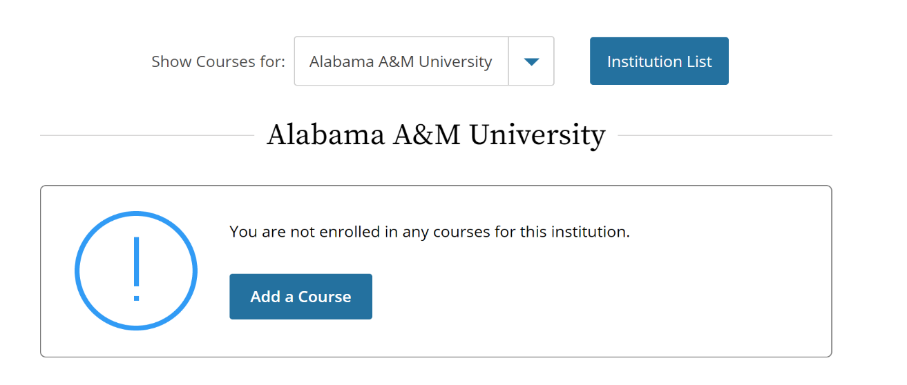

- You will ONLY answer 2 questions in this section and will need to leave all other questions blank. Scroll down to Question 6 and select NO.
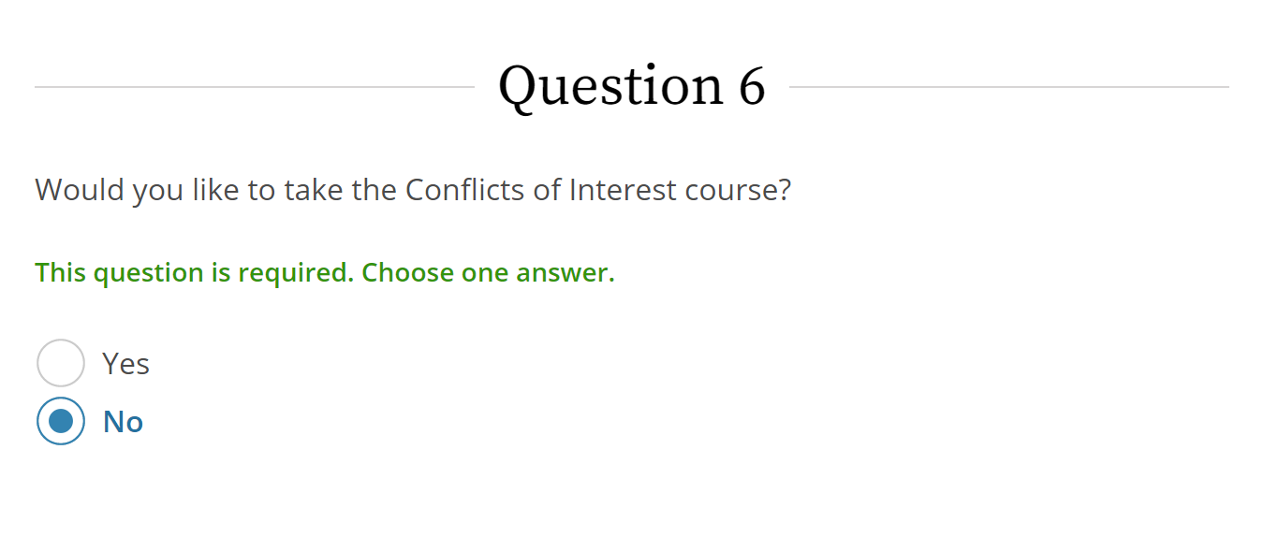

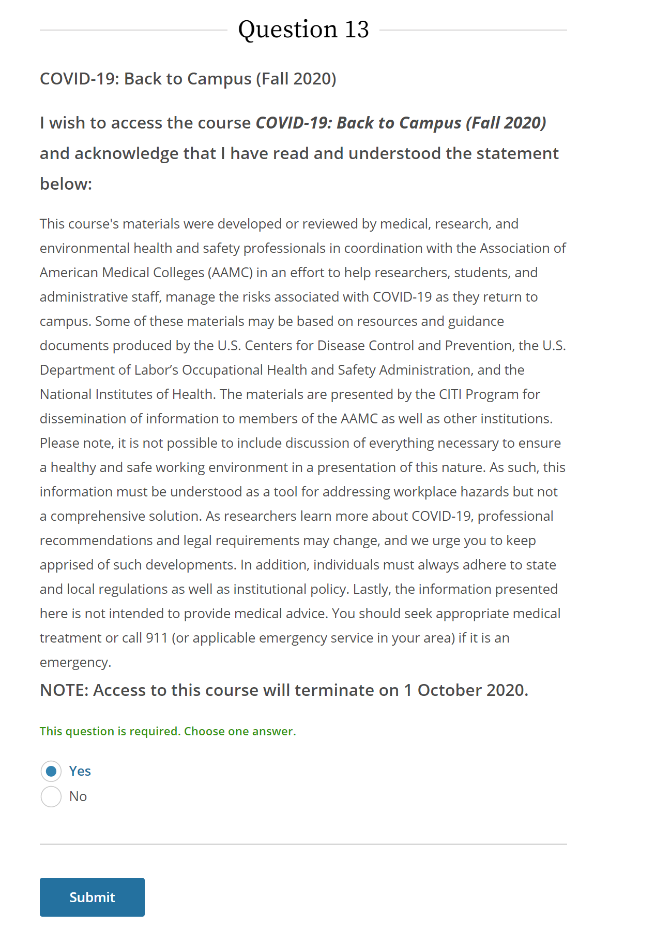
- Scroll down to Question 13, select YES and click SUBMIT.

- Your COVID -19: Back to Campus Course is now ready to begin. Click START NOW to begin your Course.
