PROPOSAL FOR ALABAMA A&M UNIVERSITY MECHANICAL SYSTEM WATER TESTING AND TREATMENT

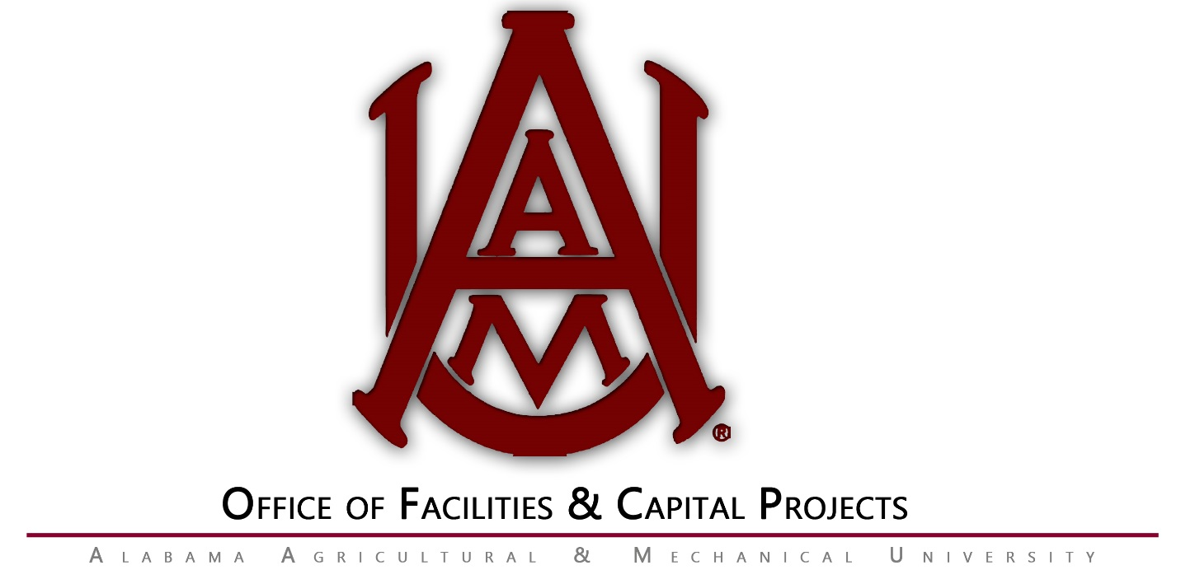
RFP# 08F-2020
Addendum I

Questions / Answers

- In the Scope of Work section #16 Performance Warranty. Can you clarify that you only need a statement of our performance guaranty or are you wanting a performance bond? Clarification: This would be the Companies warranty for services provided to protect mechanical equipment from scale and fouling.

- Section 1.1 under "Scope of Services" #2. What specifications do you require of the dry feeder systems to be used on each cooling system? Dry feeder systems are recommended but liquid feeders will be accepted.

- Section 1.1 under "Scope of Services" #3. For system that have pot feeders that are currently being used that are in unsafe or nonworking order will those be required to be replaced by bid winner? Yes Also, for system that do not currently have any type of feeder system will you require just a pot feeder or a filter feeder? It will be left to the vendor to provide the system that works best for the type of mechanical system.

- Section 1.1 under "Scope of Services" #5. States testing to only be performed during operational period on open/condenser water towers April 1st - October 31st. The bid for water treatment is only for 7 months out of the 12 months in a calendar year for cooling tower systems? Are the system drained first of November? All open loop two pipe systems are shutdown and drained before November and refilled starting mid-March.

- Section 1.1 under "Scope of Services" #13. All chemical must be dry for open water tower systems and for closed loop systems? Yes correct, liquid chemicals are acceptable but spill protection shall be provided.

- Section 1.1 under "Scope of Services" #15. Want to clarify that storage of water treatment chemical onsite is allowed? Chemicals are allowed in the mechanical rooms where space is available, and storage of chemicals does not interfere with the operation of equipment in the mechanical rooms.

- Section 1.1 under "Qualification of bidders" #1. The bidding companies do not have to have an office location in Huntsville/Madison area? This section reads as “All bidding companies must be engaged primarily in the business of commercial or industrial cooling tower/boiler water treatment chemicals and services. The bidder must have operated as a water treatment service company for a period of not less than five (5) years.”, there are no requirements on company location, but companies will have to be able to respond within two(2) hours if required.

End of Addendum 1

