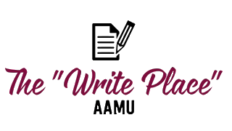

Writing Consultant (Tutor) Job Description
The “Write Place” peer tutor/writing consultant is responsible for maintaining an upbeat and positive environment, keeping the Center neat, attending to the needs of clients and collaborating with students and staff. Must be possess strong writing and communications skills and have a willingness to learn.

- Consult with students, offering feedback & suggestions for their writing tasks
- Research, create & identify writing resources
- Assist with class visits to promote writing resources
To Be Eligible Applicants must:

- Maintain a minimum GPA of 3.0
- Have successfully completed (earned an A or B) in both sections of Freshman Composition and demonstrated above average ability in any subsequent writing courses taken during undergraduate and graduate study.
- Exhibit strong interpersonal skills
Application Packet should include:
- A cover letter that describes your academic and extracurricular interests and commitments
- an unofficial transcript
- a prose writing sample (2–5 pages in length). The best samples are generally ones that present an argument of some kind rather than a summary.
Job Requirements:
- Complete an initial training then ongoing training throughout the term of employment
- Demonstrate engagement and growth in the position in order to maintain employment.
How to Apply:
- Complete the Write Place application form
- Email cover letter, unofficial transcript (download from Banner) and prose sample. Address to “Writing Center Director” write.place@aamu.edu and put in the subject line “Writing Center job application”
- Follow these instructions for TAN application (Note: to work as a Writing Center tutor you must also apply to the tutorial assistance network (TAN). This application is in addition to the Write place form completed in step 1)

