**WELCOME!**

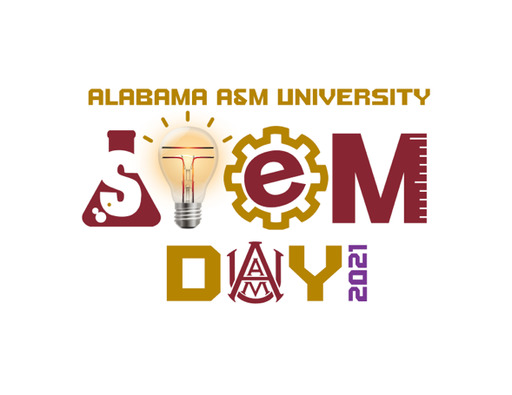

**~PROGRAM~**

|  |  |  |
| --- | --- | --- |
| 8:00 am – 8:55 am | Welcome | **Salam Khan, Ph.D.,**  Chair, STEM Day 2021  **Andrew Hugine, Ph.D.,**  President, Alabama A&M University  **Lloyd Walker, Ph.D.,**  Dean, College of Agricultural, Life, and Natural Sciences |
|  |  | **Zhengtao Deng, Ph.D.,**  Dean, College of Engineering, Technology, and Physical Sciences  **Lena Walton, Ph.D.,**  Dean, College of Education, Humanities, and Behavioral Sciences |
|  |  | **Matthew Edwards, Ph.D.,**  Founder, STEM Day |
|  | Introduction of Speaker | **Japhe Jelks,** SGA President  Senior, Biology |
|  | STEM Day 2021 Speaker  Special Presentation | **Patrick W. Burden,**  The Boeing Company Director, Army and Special Operations Forces, Field Marketing, Global Sales and Marketing Defense, Space & Security  **Salam Khan, Ph.D.** |
| 9:00 am – 12:00 pm | STEM Poster Viewing / Graduate Oral Presentation/ Judging | Whova |
| 12:00 pm – 1:00 pm | Lunch/Musical | Whova |
| 1:00 pm – 2:00 pm | STEM Day Awards Ceremony | Whova |