How to Login to Your Banner Account
step
Step 1: Go to the AAMU home page. https://www.aamu.edu/myaamu/index.html
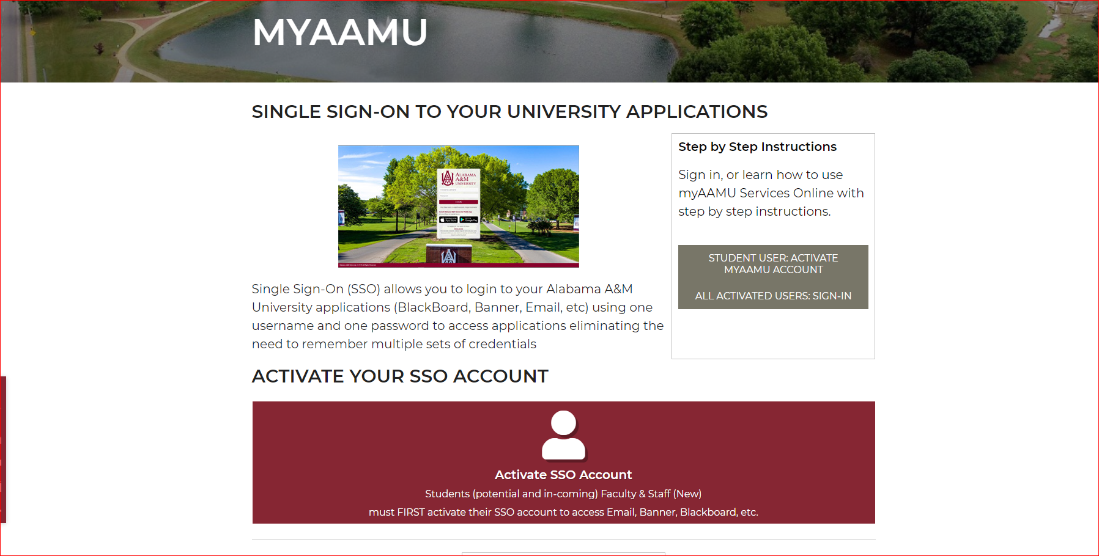

Step 2: Click on Activate Your SSO Account or Sign-In to SSO using your A-number and PIN.

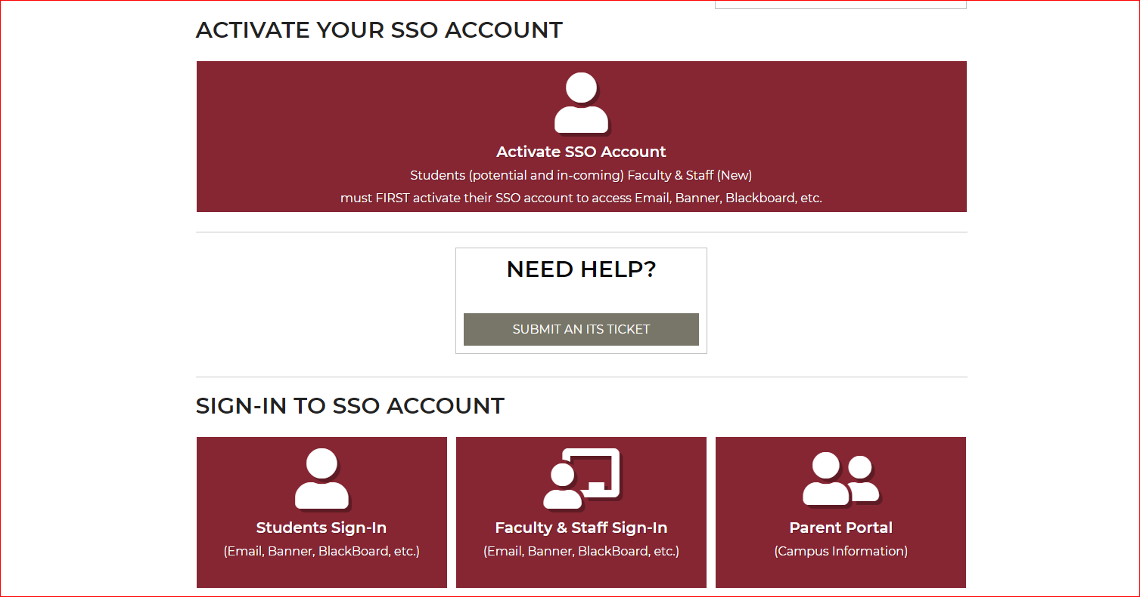

Step 3: Look for the App that says Banner Self Service, and click on it.

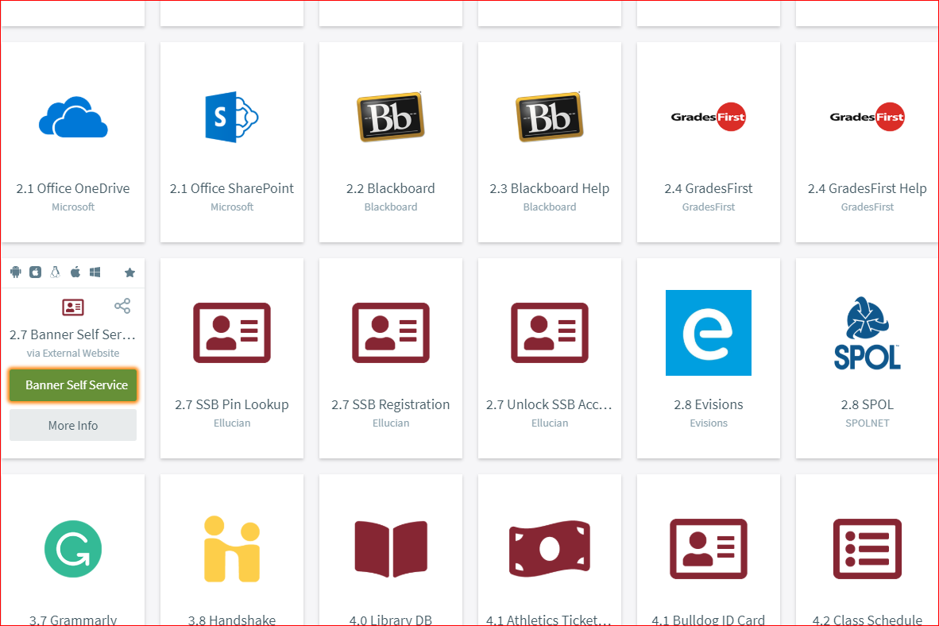

Step 3: After logging into your Self Service Banner, look for the student tab. Once the student tab is located, click on it.

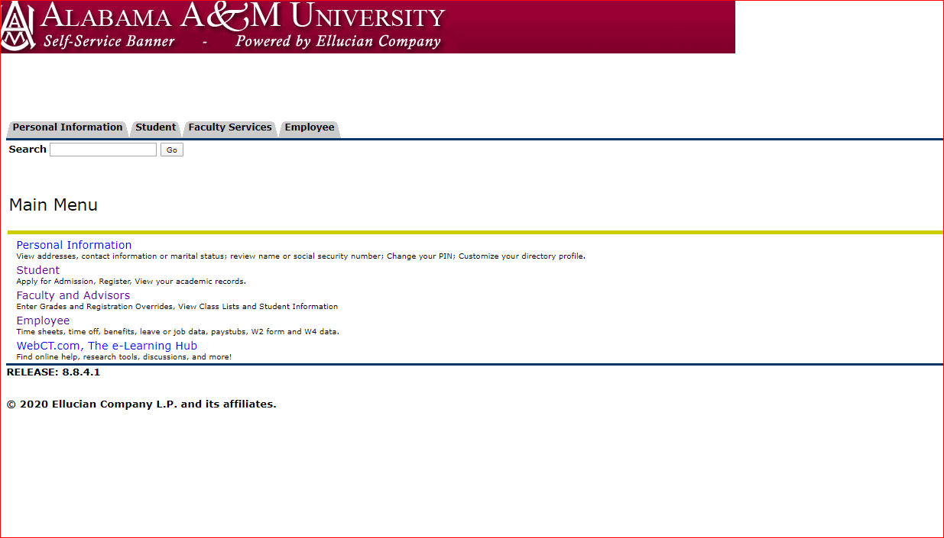

Step 4: You should see the Housing Application link listed inside your Self-Service Banner Account.
Next, click on the Housing Application link, and if you are eligible to apply you will be granted access to complete the Housing Application Process. Congratulations! You are on your way!

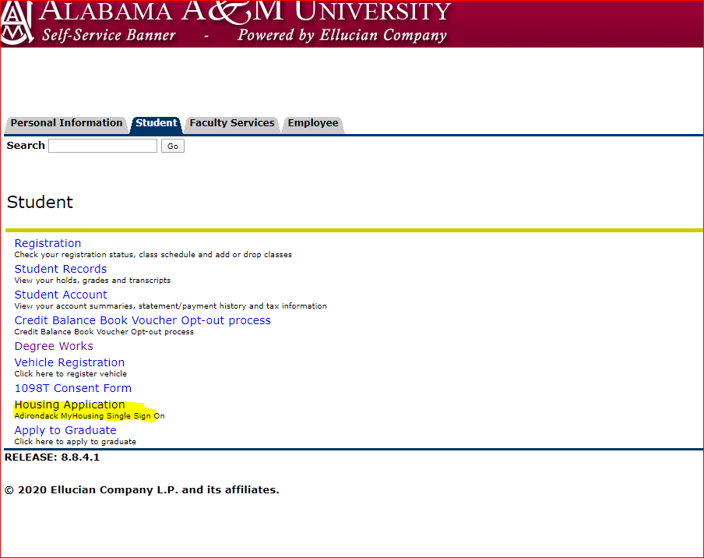
Step 5: You can also locate the housing portal in the apps area.
