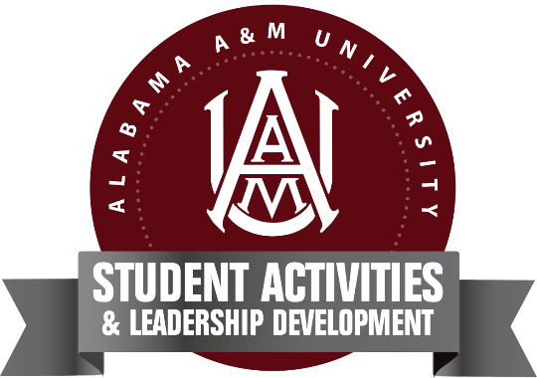
Alabama Agricultural & Mechanical University
Registered Student Organization Registration Guide
The Office of Student Activities requires all student organizations to register each Fall semester to maintain active status on campus. This year, we are shifting to utilize Presence (Bulldog Connect) for student organization management. Presence will be used for organization registration, event registration, forms, and more.
Below is a guide to submitting your organization’s registration. All organizations (including orgs that fall under departments) are asked to submit their organization’s registration for activation by Thursday, August 31st at 5pm.
Organization Minimum Requirements
- A minimum of 10 enrolled AAMU students who are current or interested members of the organization (each student must have at least a cumulative 2.5 GPA)
  - All members must be currently enrolled AAMU students.
- Documented 200 hours of community service (performed as a group) from the previous academic year (new organizations are not required to have service hours prior to activation)
  - NOTE: All current organizations must have met 200 service hours during the 2022-23 academic year. Hours will be verified for all orgs through the Office of Service & Learning.
  - For the 2023-24 academic year, all active organizations must complete 200 service hours from August 17, 2023-April 1, 2024. We strongly encourage 100 hours per semester. Service training will take place during the RSO Leadership Summit.
- Constitution and Bylaws for the organization
- Organization hierarchy (president, vice president, etc.)
- Advisors (see requirements in Advisor Requirements section)
- Proposed calendar of events for the upcoming school year
  - In order to host events on campus, organizations must be in active status on campus.
- Receive approval from the Office of Student Activities and Leadership Development.

Organization Registration Process
Please follow the steps below to create your organization’s registration.
- Visit aamu.presence.io.
- Create your individual Presence profile in the student portal. If you created a profile to vote in the SGA/Miss AAMU Election in April, then you will use your same log in.
  - NOTE: All students will need to create their profile, so please go ahead and encourage your members to create their profiles.
- Once you log in, click the “Forms” at the top of the page. Then click on the “Organization Registration” Form.
- Enter all of the required information (organization mission, roster, advisors, etc.). Please note: all required fields must be completed in order to submit the form for approval.
  - Upload your organization’s constitution and/or bylaws.
  - You may save your form and come back to it before submitting if you need to. But be sure to click save at the top so you do not lose your information. We would recommend clicking save throughout the
- Once your form is complete, click on the green "Submit" tab in the upper right-hand corner.
- You will be directed to a page where you will see your completed form. If anything needs to be changed, you can select the edit tab in the upper right-hand corner and you will be able to edit your Organization Registration. If not, click "Submit for Approval". Once your submissions is approved, your organization will be created! You'll receive an email confirming the approval (or denial) of your request.
  - If you request has been denied, please review the denial reason contained within the confirmation email.
- Once your organization’s registration has been approved, then your organization’s page will automatically be created (similar to having your org’s social media page).

Organization Registration Process (Presence pages that exist)
There are several RSOs that already have organization pages that were created a few years ago in Presence. Please review the list below to see if your organization’s page already exists. If your organization is on the list, you will NOT need to follow all of the steps listed above. You will need to edit your organization and make all necessary updates. Here is a link with instructions about how to edit your organization: http://learn.presence.io/en/articles/2426933-editing-an-organization.
Please have your current president or advisor to contact Jessica.brown1@aamu.edu so I can transition the organization to you if you do not have proper access.
Pages that currently exist in Presence but require updates/transition:
- The National Society of Black Engineers (NSBE)
- Eta Kappa Tau Engineering and Technology Fraternity, INC.
- Alabama A&M University Pre-Alumni Association
- AAMU Student Activities Board
- Gamma Sigma Sigma National Service Sorority Incorporated
- Psychology Club
- Kappa Iota Chapter of Sigma Gamma Rho Sorority Inc.
- Men of America Nurturing & Ushering Progress, Incorporated (M.A.N.U.P., Inc.)
- Melanated Doctors of America
- Delta Sigma Theta Sorority, Incorporated.
- The National Society of Leadership and Success
- The Office Community College Relations and Global Initiatives
- Collegiate 100 "Quiet Storm" Chapter
- The Gamma Phi Chapter of Kappa Alpha Psi Fraternity Incorporated
- Zeta Phi Beta Sorority, Incorporated
- Eta Kappa Tau Engineering and Technology Fraternity, INC
- Alpha Phi Alpha Fraternity, Inc.
- The Alabama A&M University Southern Belles
- Alabama A&M Gospel Choir
- Phi Beta Lambda Business Fraternity Incorporated, XiXi Chapter
- The Gamma Epsilon Chapter of Phi Beta Sigma Fraternity, Incorporated
- Omega Psi Phi Fraternity, Incorporated
- The Gamma Mu Chapter of Alpha Kappa Alpha Sorority, Inc.
- Alima Dance Company
- Pershing Angels
- The Gamma Epsilon Chapter of Phi Beta Sigma Fraternity, Incorporated

Advisor Requirements
Below are advisor reminders and updates.
- All student organizations must have at least one advisor who is employed by Alabama A&M University.
  - NPHC organizations must have a minimum of 3 advisors.
  - Social Greeks must have a minimum of 2 advisors.
  - All other organization categories must have a minimum of 1 advisor. However, we strongly encourage organizations to have at least 2 advisors as advisors will still be required to be on site for organization events.
  - Organizations are allowed to have graduate student advisors (except NPHC). However, graduate students may NOT serve as the primary advisor for the organization.
- Each advisor must submit the Advisor Verification Form by August 31st as part of the Organization Registration process. Click here to access the form.
- Advisors will be required to attend the RSO Advisor Training scheduled for Friday, August 24th from 1:00-3:00pm. More details to come.

Student Organization Support
All RSOs will indirectly report through the Office of Student Activities & Leadership Development. RSO policies and procedures will be defined in the RSO Handbook.
RSO Senators under the Student Government Association will assist in supporting all student organizations. Presidents will be added the RSO Presidents GroupMe and will be required to participate in RSO Meetings throughout the year.
- Erianna Sanders | erianna.sanders@bulldogs.aamu.edu
- Myles Jernigan | myles.jernigan@bulldogs.aamu.edu

Contact studentactivities@aamu.edu for general RSO support.

