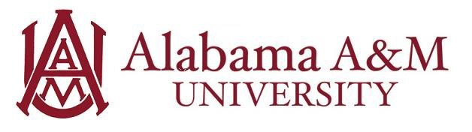

Job Title: Athletic Compliance Student Employee
Department: Department of Athletics
Hourly Rate: $12/hour
Work Hours: Up to 20 hours per week (flexible with class schedule)

Position Summary:
The Athletics Compliance Student Employee will assist the Department of Athletics in upholding NCAA, SWAC, and Title IX compliance standards. The Student Employee will work closely with the compliance team to help ensure the academic and personal success of student-athletes while supporting the department’s mission of integrity and excellence. This position provides an opportunity to gain valuable experience in sports governance, policy interpretation, and institutional compliance management.

Purpose and Learning Outcomes:
- Understand the regulatory framework governing NCAA Division I athletics, including eligibility, amateurism, and recruiting rules.
- Develop practical experience in compliance monitoring, documentation, and reporting.
- Strengthen attention to detail, organization, and professional communication skills.
- Gain insight into the Student Employeeal operations and legal considerations of intercollegiate athletics.
- Learn how ethical decision-making and policy enforcement contribute to a successful athletics program.

Key Responsibilities:
- Assist with day-to-day compliance operations, including tracking student-athlete eligibility and maintaining required documentation.
- Help manage and update compliance software systems.
- Support preparation and distribution of rules education materials for coaches, staff, and student-athletes.
- Assist in monitoring recruiting activities, playing and practice seasons, and amateurism certification.
- Participate in audits and reviews to ensure adherence to NCAA, SWAC, and institutional policies.
- Maintain confidentiality and uphold professional standards in all tasks.

Qualifications:
Preferred knowledge, skills, and personal qualifications:
- Pursuing a major in Sports Management, Public Administration, or a related field.
- Interest in pursuing a career in collegiate athletics, legal affairs, or athletic administration.
- Familiarity with NCAA rules or previous experience in a collegiate athletics setting.
- Strong writing, research, and communication skills.

Required Qualifications:
- Must be a currently enrolled undergraduate or graduate student at Alabama A&M University.
- Minimum cumulative GPA of 2.5.
- Strong attention to detail, organizational ability, and commitment to confidentiality.
- Proficiency in Microsoft Office Suite (Excel, Word, Outlook).
- Availability to work 15-20 hours per week, including some flexibility during peak compliance periods.

Experience Gained in this Role:
By the end of the employment period, the student will have developed skills in:
- Communication – The student will be able to communicate professionally when delivering policy updates or explaining rules to coaches and student-athletes.
- Professionalism – The student will demonstrate effective time management and problem solving skills.

