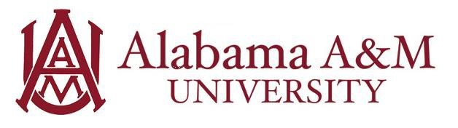

Job Title: Facility Operations Student Employee
Department: University Fitness and Recreation Center
Hourly Rate: $12/hour
Work Hours: Up to 20 hours per week (flexible with class schedule)

Position Summary:
The Facility Operations Student Employee supports the day-to-day management and operational functions of the University Fitness and Recreation Center at Alabama A&M University (AAMU). This role involves assisting staff at the front desk, maintaining facility and equipment standards, and ensuring compliance with department policies and procedures. This position is ideal for students interested in recreation management, fitness facility operations, or general business administration.

Purpose and Learning Outcomes:
- Gain practical experience in recreation and facility management
- Develop problem-solving and organizational skills in a fast-paced environment
- Strengthen communication and customer service abilities
- Learn how to support daily operations within a multi-use campus facility
- Build professional experience in team collaboration and event support

Key Responsibilities:
- Assist with daily operations such as processing membership applications, room reservations, work order tracking, inventory, and general facility oversight
- Support and help coordinate special events, including intramural tournaments, practices, and other programming
- Maintain facility safety and cleanliness by inspecting equipment, identifying maintenance needs, and tracking supply inventory
- Collect and compile participation data and assist in preparing reports
- Support fitness and wellness staff with day-to-day tasks as needed
- Follow and implement emergency protocols and safety procedures when necessary
- Attend all required meetings, trainings, and scheduled shifts
- Perform additional duties as assigned or aligned with areas of interest and growth

Qualifications:
Preferred knowledge, skills, and personal qualifications:
- Pursuing a degree in Sport Management, Exercise Science, Physical Education, Business, Hospitality, Management, or a related field
- Strong organizational and multitasking skills
- Ability to adapt in a dynamic, diverse, and team-oriented environment
- Proficient written, verbal, and interpersonal communication skills
- Familiarity with Microsoft Office Suite and ability to use a PC in an office setting

Required Qualifications:
- Enrolled as a full-time student at Alabama A&M University
- Able to commit 15–20 hours per week (schedule determined by supervisor)
- Availability to work a flexible schedule including days, nights, and weekends
- Commitment to upholding University and departmental policies and mission
- Ability to maintain confidentiality when handling sensitive information
- Friendly and professional demeanor with a customer service focus

Experience Gained in this Role:
By the end of the employment period, the student will have developed skills in:
- Communication: The student will be able to engage with a variety of individuals in a professional and helpful manner.
- Critical Thinking: The student will effectively manage multiple tasks, manage deadlines, and solve problems efficiently.

