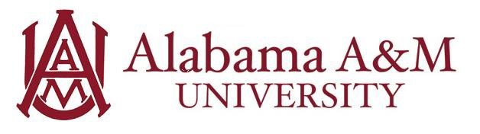

Job Title: Health Promotion Event Student Employee
Department: University Fitness and Recreation Center
Hourly Rate: $12/hour
Work Hours: Up to 20 hours per week (flexible with class schedule)

Position Summary:
The Health Promotion Event Student Employee supports the University Fitness and Recreation Center at Alabama A&M University (AAMU) in planning, delivering, and evaluating health and wellness programs. This role focuses on promoting physical activity, healthy eating habits, and preventative health strategies. Student Employees will contribute to program development, event coordination, and health communication efforts while gaining practical experience in campus wellness initiatives.

Purpose and Learning Outcomes:
- Develop experience in event planning and health promotion strategy
- Strengthen communication and customer service skills in a wellness-focused setting
- Gain hands-on practice in outreach and public engagement
- Learn how to manage responsibilities in a dynamic team environment
- Understand the role of campus recreation in student well-being and preventive health

Key Responsibilities:
- Support the creation and delivery of fitness, nutrition, and wellness-related programs and events
- Assist with logistics such as participant registration, space reservations, and preparation of event materials
- Contribute to marketing efforts by helping design and distribute promotional content
- Prepare presentations, flyers, and Student Employeeal documents using Microsoft Office tools
- Provide excellent customer service by greeting and assisting visitors in a friendly and professional manner
- Help maintain daily operations and assist facility staff as needed
- Follow emergency procedures and assist during safety-related situations when necessary
- Attend scheduled meetings, trainings, and team development sessions
- Maintain confidentiality of staff, participants, and sensitive information
- Perform additional duties as assigned or based on specific areas of interest

Qualifications:
Preferred knowledge, skills, and personal qualifications:
- Currently pursuing a degree in Sport Management, Communications Media, Marketing, Nutrition, Hospitality Management, or a related field
- Strong organizational skills and the ability to manage multiple responsibilities at once
- Comfortable working in a fast-paced, diverse, and evolving environment
- Effective written, verbal, and interpersonal communication skills
- Proficient in Microsoft Office Suite and other standard office tools

Required Qualifications:
- Must be enrolled as a full-time student at Alabama A&M University
- Able to work 15–20 hours per week (schedule determined by supervisor)
- Flexible availability, including occasional nights and weekends as needed
- Committed to upholding University policies and the mission of the University Fitness and Recreation Center
- Ability to maintain professionalism and confidentiality
- Friendly, customer-oriented demeanor and a strong sense of responsibility

Experience Gained in this Role:
By the end of the employment period, the student will have developed skills in:
- Leadership: The student will be able to take initiative when different challenges arise, and delegate tasks to complete projects on time.
- Equity & Inclusion: The student will be able to encourage others, show respect for diverse perspectives, and promote an inclusive and collaborative team culture.

