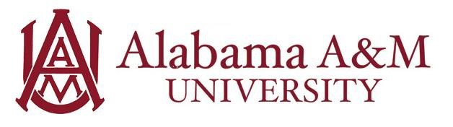

Job Title: Student Assistant
Department: Human Resources
Hourly Rate: $12/hour
Work Hours: Up to 20 hours per week (flexible with class schedule)

Position Summary:
The Student Assistant in the Alabama A&M University Human Resources (HR) office will provide essential administrative and clerical support to various HR functions, including onboarding, employee relations, benefits, and data management. This role offers a valuable opportunity to gain practical experience in the field of human resources within a higher education setting. The assistant will learn about HR best practices, compliance, and the importance of confidentiality.

Purpose and Learning Outcomes:
- Develop a foundational understanding of core human resources functions and their role within a large organization.
- Enhance administrative and organizational skills through managing HR documentation, data entry, and office procedures.
- Gain practical experience in maintaining confidentiality and handling sensitive employee information with discretion.
- Cultivate professional communication and interpersonal skills through interactions with HR staff, university employees, and job applicants.
- Learn about compliance requirements and policies related to employment in a higher education environment.

Key Responsibilities:
- Provide general administrative support, including filing, scanning, copying, and organizing HR documents (e.g., personnel files, applications).
- Assist with data entry into HR information systems, ensuring accuracy and completeness of employee records.
- Maintain the organization and cleanliness of the HR office and common areas.
- Answer routine phone calls and direct inquiries to the appropriate HR specialist or department.
- Assist with special projects, research tasks, or event planning as assigned by HR staff.
- Help prepare and distribute internal communications related to HR policies or announcements.
- Strictly adhere to all university policies, procedures, and confidentiality guidelines regarding employee information.

Qualifications:
Preferred knowledge, skills, and personal qualifications:
- Interest in Human Resources, Business Administration, or a related field.
- Previous experience in an office environment or with administrative tasks.
- Demonstrated ability to maintain a high level of discretion and professionalism.
- Proactive, detail-oriented, and capable of managing multiple tasks efficiently.

Required Qualifications:
- Must be a currently enrolled undergraduate or graduate student at Alabama A&M University.
- Minimum cumulative GPA of 2.5.
- Excellent interpersonal and communication skills (written and verbal).
- Strong organizational skills and attention to detail.
- Proficiency in basic computer applications, including Microsoft Office Suite (Word, Excel, Outlook).
- Ability to work 15-20 hours per week

Experience Gained in this Role:
By the end of the employment period, the student will have developed skills in:
- Communication – The student will communicate in a clear and organized manner so that others can effectively understand.
- Professionalism – The student will show a high level of dedication toward excelling in their duties.

