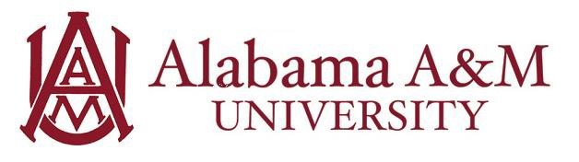

Job Title: ITS Help Desk Student Assistant
Department: AAMU Information Technology Services
Hourly Rate: $12/hour
Work Hours: Up to 20 hours per week (flexible with class schedule)

Position Summary:
The Student Assistant for the Alabama A&M University ITS Help Desk will provide essential first-level technical support and customer service to the university community, including students, faculty, and staff. This role is crucial in enabling the effective use of information technology across the campus. The assistant will gain practical experience in IT support, troubleshooting, and professional communication.

Purpose and Learning Outcomes:
- Develop a foundational understanding of common IT support processes and best practices in a higher education environment.
- Enhance technical troubleshooting and problem-solving skills for a variety of hardware, software, and network issues.
- Gain practical experience in delivering high-quality, customer-focused IT support through various communication channels.
- Cultivate effective communication, active listening, and interpersonal skills while building trust and rapport with IT users.

Key Responsibilities:
- Provide first-level technical support for common IT issues, including network connectivity, software installation, password resets, and basic hardware troubleshooting.
- Respond to help desk inquiries via phone, email, and in-person, logging all interactions accurately in the ticketing system.
- Escalate complex technical issues to appropriate ITS staff or specialized support teams.
- Assist users with general IT questions and guide them to relevant university resources or documentation.
- Support the setup and breakdown of IT equipment for events, classrooms, or labs as needed.
- Adhere to ITS policies and procedures, ensuring data security and confidentiality.
- Contribute to creating an environment of mutual respect, collaboration, and dedication to customer service.

Qualifications:
Preferred knowledge, skills, and personal qualifications:
- Interest in information technology, computer science, or a related field.
- Previous experience in a help desk, customer service, or technical support role
- Familiarity with common operating systems (Windows, macOS), productivity software (Microsoft Office, Google Workspace), and basic networking concepts.
- Demonstrated ability to learn new technologies quickly and adapt to changing technical environments.
- Proactive, detail-oriented, and capable of managing multiple tasks.

Required Qualifications:
- Must be a currently enrolled undergraduate or graduate student at Alabama A&M University.
- Minimum cumulative GPA of 2.5.
- Excellent interpersonal and communication skills (written and verbal) to effectively explain technical concepts to non-technical users.
- Strong problem-solving abilities and a methodical approach to troubleshooting.
- Ability to work 15-20 hours per week

Experience Gained in this Role:
By the end of the employment period, the student will have developed skills in:
- Technology – The student will be able to apply technical skills to diagnose and resolve issues with hardware, software, and network connectivity.
- Critical Thinking – The student will be able to analyze a user’s IT issue, ask appropriate questions, and determine the potential cause and solution to the issue.

