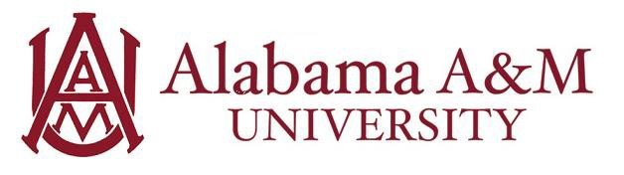

Job Title: Student Marketing & Promotions Assistant
Department: Various Campus Departments
Hourly Rate: $12/hour
Work Hours: Up to 20 hours per week (flexible with class schedule)

Position Summary:
The Student Marketing & Promotions Assistant will support departmental marketing, communications, branding, and outreach initiatives to promote programs, events, and services to the Alabama A&M University community. This role provides hands-on experience in digital marketing, event planning, content creation, and public relations. Students will gain practical skills applicable to careers in marketing, business development, communications, sports management, and student affairs.

Purpose and Learning Outcomes:
- Gain real-world experience in marketing, promotions, and communications within a collegiate setting.
- Develop skills in digital marketing, branding strategies, and fan/customer engagement.
- Strengthen abilities in event planning, coordination, and logistical support.
- Enhance professional writing, public speaking, and presentation skills.
- Learn to analyze marketing data and metrics to assess campaign effectiveness and recommend improvements.
- Cultivate strong organizational, time management, and teamwork skills while working in dynamic environments.
- Build confidence in customer service and professional interactions with diverse audiences.

Key Responsibilities:
- Assist in the development and execution of marketing and promotional campaigns for departmental programs, events, and services.
- Support social media content creation, including graphics, videos, captions, and live coverage as needed.
- Distribute promotional materials and manage on-campus advertising or tabling efforts.
- Conduct basic market research through surveys, focus groups, and direct outreach to inform departmental strategies.
- Help coordinate and execute special events, wellness campaigns, game-day promotions, or student engagement initiatives.
- Provide courteous and professional customer service to students, staff, alumni, visitors, and external partners.
- Draft and edit marketing materials, documents, presentations, and internal communications.
- Track marketing metrics and provide post-event or campaign reports with recommendations.
- Attend required meetings, trainings, and team activities to support departmental goals.
- Perform additional administrative or operational tasks as assigned to support day-to-day office functions.
Qualifications:
Preferred knowledge, skills, and personal qualifications:
- Pursuing a degree in Marketing, Communications Media, Sport Management, Business, or a related field.
- Experience with social media platforms (Instagram, X, TikTok, etc.) and design/content creation tools (e.g. Canva, Adobe Creative Suite).
- Strong organizational skills with the ability to manage multiple tasks simultaneously.
- Excellent written, verbal, and interpersonal communication skills.
- Comfortable working in fast-paced, diverse, and team-oriented environments.
- Prior involvement in campus events, student organizations, athletics, or wellness programs is a plus.

Required Qualifications:
- Must be a currently enrolled undergraduate or graduate student at Alabama A&M University in good academic standing.
- Minimum cumulative GPA of 2.5.
- Professional demeanor with punctuality, reliability, and attention to detail.
- Ability to work flexible hours, including some evenings and weekends, depending on event schedules.
- Demonstrated commitment to confidentiality, departmental policies, and university standards.
- Friendly, approachable, and service-oriented attitude.

Experience Gained in this Role:
By the end of the employment period, the student will have developed skills in:
- Technology: The student will demonstrate proficiency with design software, social media platforms, and digital marketing tools to create and distribute effective promotional materials.
- Critical Thinking: The student will evaluate campaign performance data to assess effectiveness and recommend improvements for future initiatives.

